**CSE523 Machine Learning**

**Prof. Mehul Raval**

# **Stress Detection**

**Week 3 Report**

| **Name** | **Enrolment Number** |
| --- | --- |
| Mohsinali Vijapura | AU2040080 |
| Manan Vadaliya | AU2040264 |
| Pruthviraj Dodiya | AU2040175 |
| Mitsu Sojitra | AU2040157 |

**Task performed this week:**

**Data Collection and Preprocessing**

We preprocessed the data by cleaning and normalizing the physiological data, and creating features such as mean, standard deviation, and frequency domain features.

**Model Selection and Training**

We selected a support vector machine (SVM) algorithm for our stress detection model. We trained the model using 67% of the data, and tested it on the remaining 33% with random state value of 42.

**Challenges and Solutions**

One challenge we have encountered is that when we use our stress detection model to predict stress for new, unseen data, we sometimes get incorrect results. While the model performs well on our test data, it struggles to generalize to new data.

To address this challenge, we plan to implement techniques such as cross-validation and regularization to reduce overfitting and improve the model's generalization capabilities. We will also explore the use of transfer learning and ensemble learning techniques to help the model learn from related data and improve its performance on new inputs. Additionally, we will try to focus more on data preprocessing , by removing intercorrelations , cleaning etc to increase the quality of data so that the learning becomes more accurate

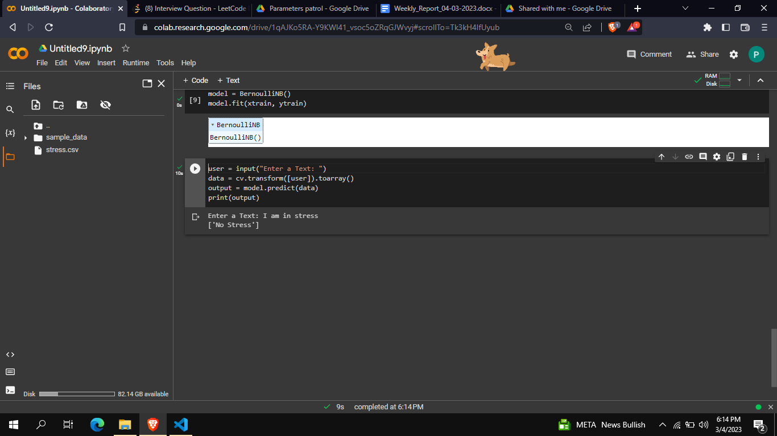

**Task to perform end in next week**

Next week, we plan to focus on improving the model's accuracy and stability by fine-tuning the BernoulliNB algorithm and further optimizing our feature selection. We also plan to begin exploring the use of deep learning algorithms for stress detection.